**Dokumentasi UC-Showroom by Daniel Aprillio 0706012010003**

1. **ERD**

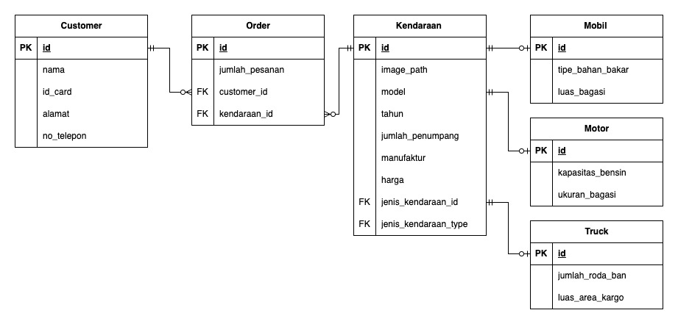

1. **Class Diagram**

1. **Testing**

* Scenario 1

Task: Create Kendaraan

|  |  |  |  |  |
| --- | --- | --- | --- | --- |
| **Step** | **Action Flow** | **Expected Result** | **Actual Result** | **Test Result** |
| 1 | Press “kendaraan” on navigation menu | Navigate to “kendaraans” page | Navigate to “kendaraans” page | Pass |
| 2 | Press “tambah kendaraan” button | Show “create kendaraan” form | Show “create kendaraan” form | Pass |
| 3 | Press “create” button without fill out any inputs | Show error “Please fill out this field” | Show error “Please fill out this field” | Pass |
| 4 | Fill out all inputs then press “create” | Navigate to “kendaraans” page and show new “kendaraan” that already created before | Navigate to “kendaraans” page and show new “kendaraan” that already created before | Pass |

* Scenario 2

Task: Read Kendaaraan

|  |  |  |  |  |
| --- | --- | --- | --- | --- |
| **Step** | **Action Flow** | **Expected Result** | **Actual Result** | **Test Result** |
| 1 | Press “kendaraan” on navigation menu | Navigate to “kendaraans” page, show list “kendaraans” | Navigate to “kendaraans” page, show list “kendaraans” | Pass |

* Scenario 3

Task: Show Kendaraan

|  |  |  |  |  |
| --- | --- | --- | --- | --- |
| **Step** | **Action Flow** | **Expected Result** | **Actual Result** | **Test Result** |
| 1 | Press “kendaraan” on navigation menu | Navigate to “kendaraans” page, show list “kendaraans” | Navigate to “kendaraans” page, show list “kendaraans” | Pass |
| 2 | Press “show” button | Show “detail kendaraan” | Show “detail kendaraan” | Pass |

* Scenario 4

Task: Edit Kendaraan

|  |  |  |  |  |
| --- | --- | --- | --- | --- |
| **Step** | **Action Flow** | **Expected Result** | **Actual Result** | **Test Result** |
| 1 | Press “kendaraan” on navigation menu | Navigate to “kendaraans” page, show list “kendaraans” | Navigate to “kendaraans” page, show list “kendaraans” | Pass |
| 2 | Press “edit” button | Show “edit kendaraan” form with all old values | Show “edit kendaraan” form with all old values | Pass |
| 3 | Press “edit” button without fill out any inputs | Navigate to “kendaraans” page without any changes | Navigate to “kendaraans” page without any changes | Pass |
| 4 | Fill out any inputs then press “edit” | Navigate to “kendaraans” page and show updated “kendaraan” that already updated before | Navigate to “kendaraans” page and show updated “kendaraan” that already updated before | Pass |

* Scenario 5

Task: Delete Kendaraan

|  |  |  |  |  |
| --- | --- | --- | --- | --- |
| **Step** | **Action Flow** | **Expected Result** | **Actual Result** | **Test Result** |
| 1 | Press “kendaraan” on navigation menu | Navigate to “kendaraans” page, show list “kendaraans” | Navigate to “kendaraans” page, show list “kendaraans” | Pass |
| 2 | Press “delete” button | Remove selected “kendaraan” from view and database | Remove selected “kendaraan” from view and database | Pass |

* Scenario 6

Task: Create Customer

|  |  |  |  |  |
| --- | --- | --- | --- | --- |
| **Step** | **Action Flow** | **Expected Result** | **Actual Result** | **Test Result** |
| 1 | Press “customer” on navigation menu | Navigate to “customers” page | Navigate to “customers” page | Pass |
| 2 | Press “tambah customer” button | Show “create customer” form | Show “create customer” form | Pass |
| 3 | Press “create” button without fill out any inputs | Show error “Please fill out this field” | Show error “Please fill out this field” | Pass |
| 4 | Fill out all inputs then press “create” | Navigate to “customers” page and show new “customer” that already created before | Navigate to “customers” page and show new “customer” that already created before | Pass |

* Scenario 7

Task: Read Customer

|  |  |  |  |  |
| --- | --- | --- | --- | --- |
| **Step** | **Action Flow** | **Expected Result** | **Actual Result** | **Test Result** |
| 1 | Press “customer” on navigation menu | Navigate to “customers” page, show list “customers” | Navigate to “customers” page, show list “customers” | Pass |

* Scenario 8

Task: Edit Customer

|  |  |  |  |  |
| --- | --- | --- | --- | --- |
| **Step** | **Action Flow** | **Expected Result** | **Actual Result** | **Test Result** |
| 1 | Press “customer” on navigation menu | Navigate to “customers” page, show list “customers” | Navigate to “customers” page, show list “customers” | Pass |
| 2 | Press “edit” button | Show “edit customer” form with all old values | Show “edit customer” form with all old values | Pass |
| 3 | Press “edit” button without fill out any inputs | Navigate to “customers” page without any changes | Navigate to “customers” page without any changes | Pass |
| 4 | Fill out any inputs then press “edit” | Navigate to “customers” page and show updated “customer” that already updated before | Navigate to “customers” page and show updated “customer” that already updated before | Pass |

* Scenario 9

Task: Delete Customer

|  |  |  |  |  |
| --- | --- | --- | --- | --- |
| **Step** | **Action Flow** | **Expected Result** | **Actual Result** | **Test Result** |
| 1 | Press “customer” on navigation menu | Navigate to “customers” page, show list “customers” | Navigate to “customers” page, show list “customers” | Pass |
| 2 | Press “delete” button | Remove selected “customer” from view and database | Remove selected “customer” from view and database | Pass |

* Scenario 10

Task: Create Order

|  |  |  |  |  |
| --- | --- | --- | --- | --- |
| **Step** | **Action Flow** | **Expected Result** | **Actual Result** | **Test Result** |
| 1 | Press “order” on navigation menu | Navigate to “orders” page | Navigate to “orders” page | Pass |
| 2 | Press “tambah order” button | Show “create order” form | Show “create order” form | Pass |
| 3 | Press “create” button without fill out any inputs | Show error “Please fill out this field” | Show error “Please fill out this field” | Pass |
| 3 | Fill out “model kendaraan” and “jumlah pesanan” inputs | “Total harga” will calculate itself realtime | “Total harga” will calculate itself realtime | Pass |
| 4 | Fill out all inputs then press “create” | Navigate to “orders” page and show new “order” that already created before | Navigate to “orders” page and show new “order” that already created before | Pass |

* Scenario 11

Task: Read Order

|  |  |  |  |  |
| --- | --- | --- | --- | --- |
| **Step** | **Action Flow** | **Expected Result** | **Actual Result** | **Test Result** |
| 1 | Press “order” on navigation menu | Navigate to “orders” page, show list “orders” | Navigate to “orders” page, show list “orders” | Pass |

* Scenario 12

Task: Edit Order

|  |  |  |  |  |
| --- | --- | --- | --- | --- |
| **Step** | **Action Flow** | **Expected Result** | **Actual Result** | **Test Result** |
| 1 | Press “order” on navigation menu | Navigate to “orders” page, show list “orders” | Navigate to “orders” page, show list “orders” | Pass |
| 2 | Press “edit” button | Show “edit order” form with all old values | Show “edit order” form with all old values | Pass |
| 3 | Press “edit” button without fill out any inputs | Navigate to “orders” page without any changes | Navigate to “orders” page without any changes | Pass |
| 4 | Change “model kendaraan” value via dropdown | “Total harga” will calculate itself realtime | “Total harga” will calculate itself realtime | Pass |
| 5 | Change “jumlah pesanan” input | “Total harga” will calculate itself realtime | “Total harga” will calculate itself realtime | Pass |
| 6 | Fill out any inputs then press “edit” | Navigate to “orders” page and show updated “order” that already updated before | Navigate to “orders” page and show updated “order” that already updated before | Pass |

* Scenario 13

Task: Delete Order

|  |  |  |  |  |
| --- | --- | --- | --- | --- |
| **Step** | **Action Flow** | **Expected Result** | **Actual Result** | **Test Result** |
| 1 | Press “order” on navigation menu | Navigate to “orders” page, show list “orders” | Navigate to “orders” page, show list “orders” | Pass |
| 2 | Press “delete” button | Remove selected “order” from view and database | Remove selected “order” from view and database | Pass |